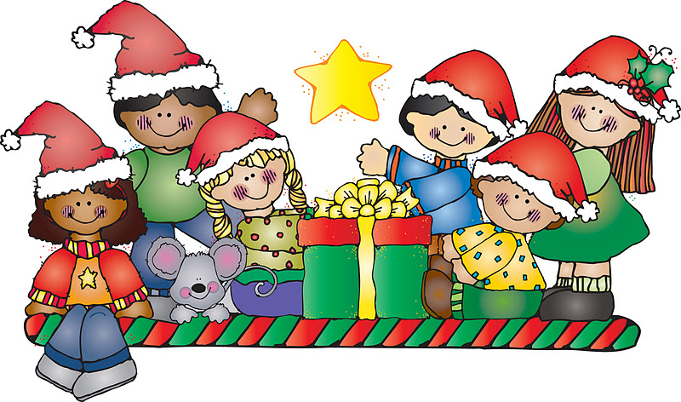
2021
Below is a list of items that will be placed in each of our holiday baskets. All donations need to be received at the Foundation Office by Monday, November 29, 2021.

Oreo Sandwich Cookies, 14 to 16 ounce package (any variety)
Hot Chocolate Mix, 6 or 10 pack box
Pretzels, 12 to 16 ounce bag
Fiddle Faddle or Crunch ’n Munch popcorn, 6 ounce box (any variety)
Hershey’s Chocolate Nuggets (any variety)
Pepperidge Farm Goldfish Crackers, 6 or 7 ounce packages (any variety)
Nestlé’s Raisinets, 3.5 ounce box
Fruit Snacks, snack size packs
Peanut Butter or Cheese snack crackers, 1 ½ to 2 ounce packages
$25.00 Grocery Gift Card
We are also asking for donations of new unwrapped toys
to be distributed to our children - ages: Infant to Teen
If you have any questions or need to have items picked up, please contact Lety Garcia at the Foundation office letyg@mhf.org or 661-250-4100

